EX NO 1: BUILD A LAN TOPOLOGY IN CISCO PACKET TRACER
Ex No 1.1:
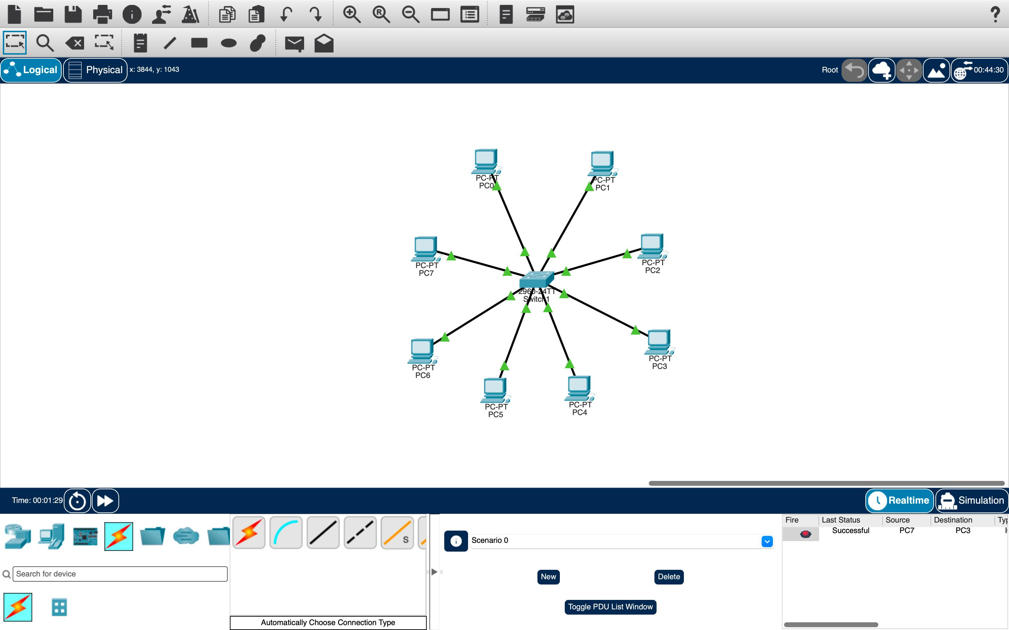

Ex No 1.2:
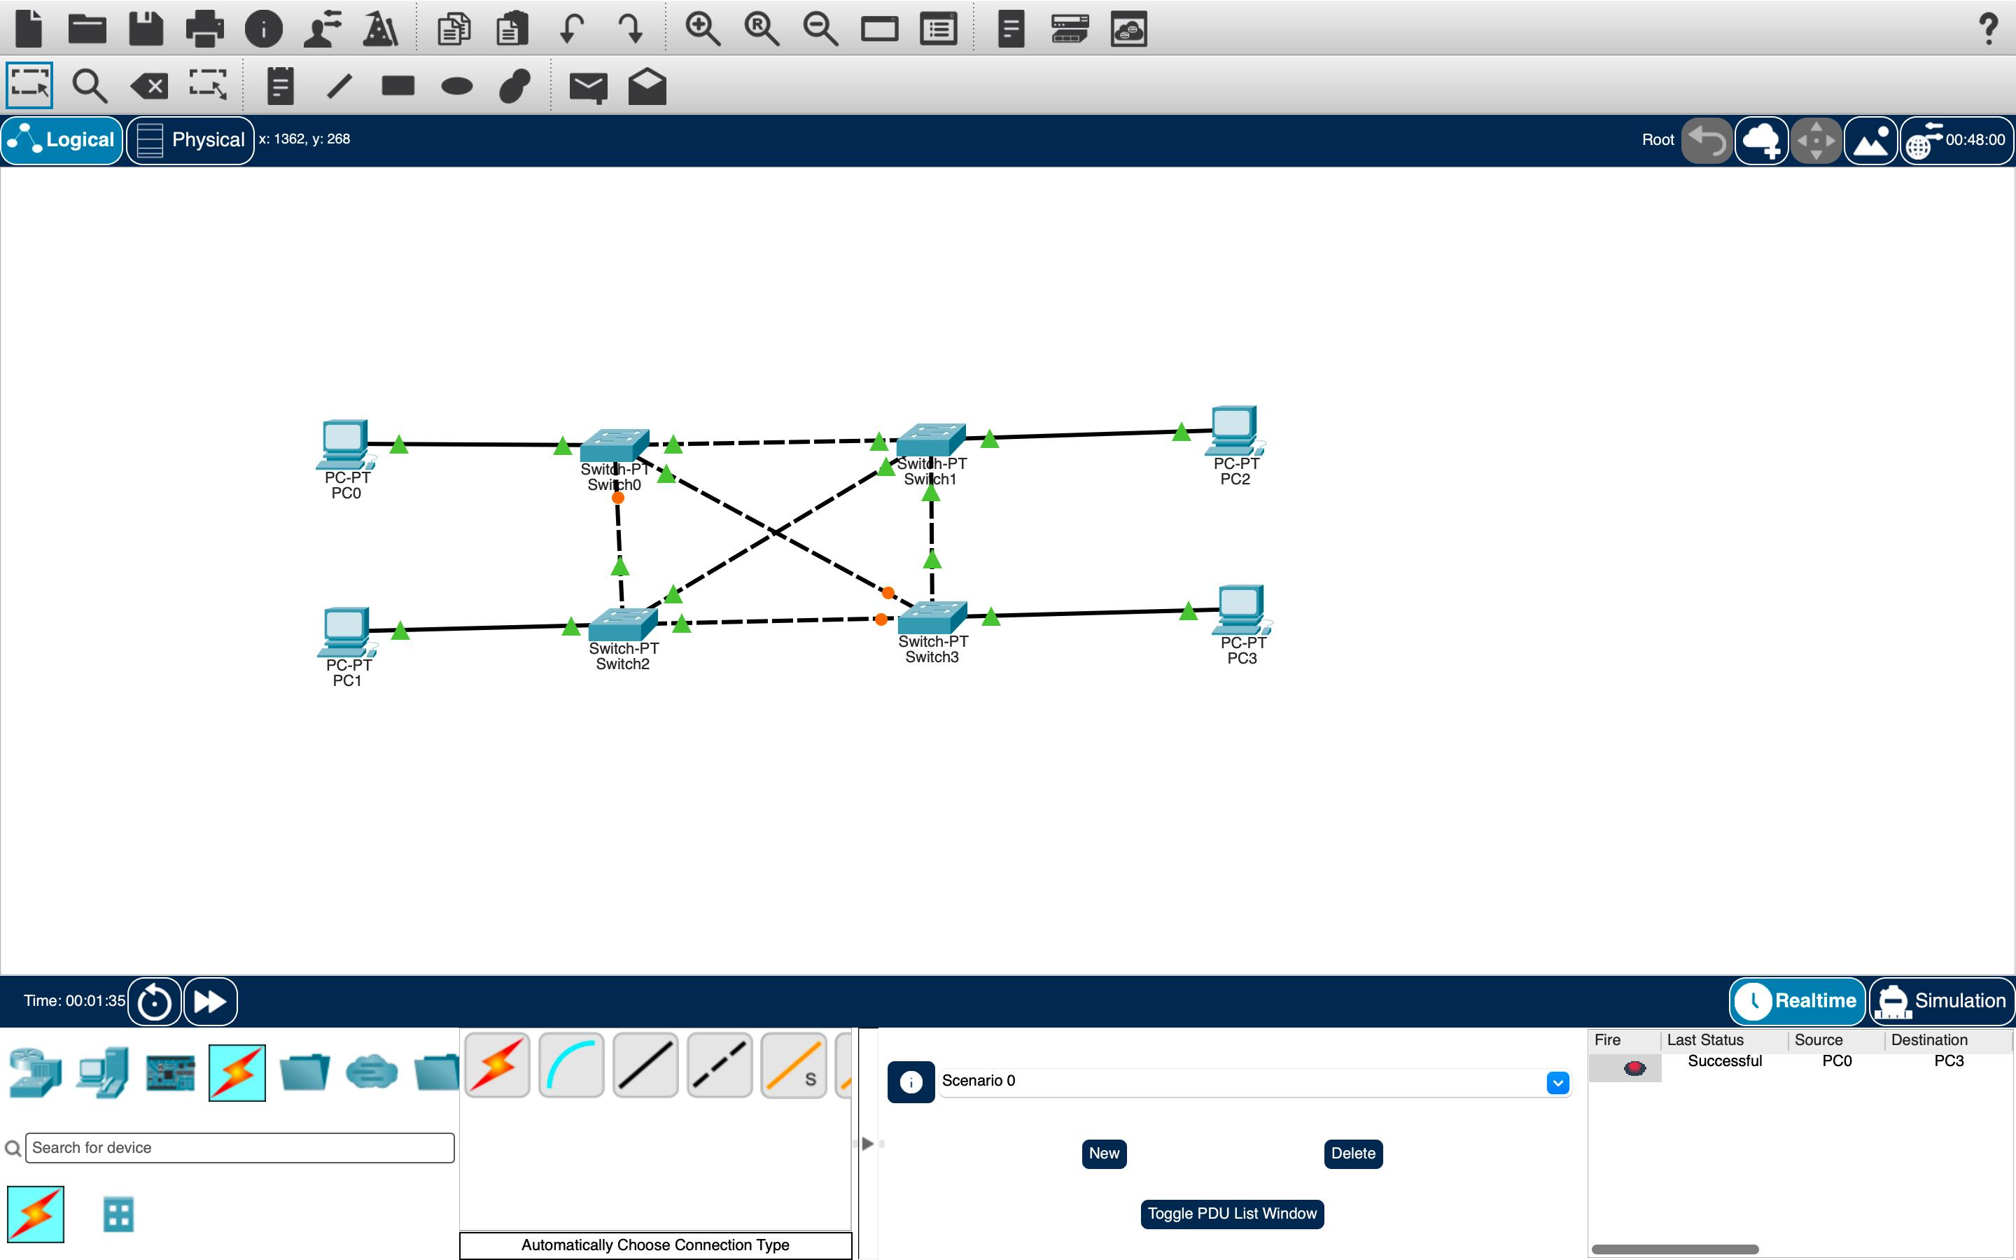

Ex No 1.3:
